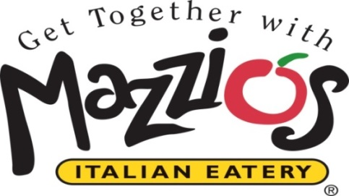

January 19, 2015

Contact: Kristy White, Waller & Company PR (918) 638-0686

**Mazzio’s Introduces New Wing Run**® **Wings in 11 Bold New Flavors**

*Mazzio’s 3-Pounder Pizza Also Returns for a Limited Time*

*Tulsa, Okla.* – Wing lovers get excited – Mazzio’s is co-branding with Wing Run® Wings to offer a choice of new boneless or traditional wings in a wide variety of flavors starting January 19.

Mazzio’s Wing Run® Wings are made to order with a choice of 11 great flavors, including Garlic Parmesan, Sweet BBQ, Spicy BBQ, Honey Mustard, Sesame, Sweet Chili, and Lemon Pepper – last year’s Wingapalooza “Best Original Recipe” winner. Also, four Buffalo flavor options are available and range from level “1” to “4” on a Mach scale for spiciness.

Wing Run® Wings are available in a 5-piece snack with one flavor, or in a 10-piece small, 15-piece medium, or 20-piece large order, each with two flavors. For a larger group, choose a 50-piece option from Mazzio’s new Catering Menu, with one to three flavors.

Wing Run® Wings have been a Tulsa favorite since 2003. Those great wings that were previously only available at WingRun Café are now available at Mazzio’s, in all 11 flavors, using time-tested recipes.

“Pizza and wings go hand-in-hand so we are excited to be adding the bold flavors of Wing Run® Wings to Mazzio’s extensive menu line-up,” said Sheri Miksa, president and CEO of Mazzio’s. “These flavorful, craveable wings are proven winners and have been “fan favorites” in our hometown of Tulsa for over 10 years.”

Mazzio’s is also bringing back its popular 3-Pounder Pizza for a limited time. And, guests wanting the best of both worlds can order the new MegaFeast, which features Mazzio’s 3-Pounder Pizza, 5 boneless Wing Run® Wings with choice of flavor, and a 9” pan of Mazzio’s new freshly-baked brownies, all bundled together for only $22.99.

**About Mazzio’s LLC**

With 140 restaurants in 10 states, Tulsa-based Mazzio’s LLC was established in 1961 and is the parent company of the Mazzio’s Italian Eatery and Oliveto Italian Bistro brands. The corporation was founded in Tulsa, Oklahoma by the late Ken Selby and ownership remains in his family today.

Mazzio’s Italian Eatery’s 137 locations offer expedited service and convenience, great value, and high quality menu items served in a warm and inviting fast casual setting, including some full-service locations. The family-friendly menu features Mazzio’s signature fresh salad bar and world-famous Ranch dressing, numerous varieties of pizza, pastas, hot sandwiches, starters like Wings of Fire® and Calzone Rings® plus kids meals for lunch and dinner, making it a perfect choice for dine-in, carryout, delivery or large groups and catering.

To view our full menu, order online or get more information about Mazzio’s Italian Eatery, visit [www.mazzios.com](http://www.mazzios.com). Or download the Mazzio’s mobile app, and enjoy ordering “on the go”.

**About Oliveto Italian Bistro**

The Oliveto Italian Bistros, with two locations in Oklahoma and one in Texas, provide artisan-inspired dishes in an upscale neighborhood dining setting. Open for lunch, dinner and later, the bistro menu boasts appetizers like our signature Bruschetta “Sundae”, Woodstone® pizzas, soups, salads, outstanding chicken, seafood and pasta entrées, desserts and a wide variety of wines, beers and cocktails. To view our full menu or get more information about Oliveto, visit [www.olivetobistro.com](http://www.olivetobistro.com).